**Name of Project**

**Name of students**

# PROJECT PROBLEM STATEMENT

Students often find it hard to review and remember handwritten notes. Turning those notes into study tools like flashcards takes a lot of time and effort. This project aims to solve that by using AI to automatically turn handwritten notes into notecards and quizzes that help with learning and retention.

# CONCISE DESIGN OVERVIEW

The solution is a mobile app built with React Native. It uses Firebase for user login and to store progress. Users take a picture of their notes. The image is encoded and sent to an API. The API sends the notes to ChatGPT, which creates notecards and quiz questions. These are shown in the app, and user stats are saved and tracked through Firebase.

# SCOPE STATEMENT

**S – Specific:** The app will allow users to take pictures of handwritten notes and automatically convert them into digital notecards and quizzes.

**M – Measurable:** Each uploaded note will generate a minimum of 5 notecards and 3 quiz questions, and user progress will be tracked after each quiz session.

**A – Achievable:** The app will be developed using React Native and Firebase, with realistic weekly goals that fit within a 7-week school timeline and available tools.

**R – Relevant:** The project supports students by turning their notes into study tools, making learning more efficient and helping with long-term retention.

**T – Time-bound:** All core features (upload, conversion, quiz generation, and tracking) will be completed, tested, and functional by the end of week 6, with final improvements in week 7.

# TIMELINE

| **Week** | **Task** |
| --- | --- |
| 1 | Finalize design and set up Firebase |
| 2 | Build the app interface and login |
| 3 | Add image upload and Base64 conversion |
| 4 | Connect to API and test response |
| 5 | Show notecards and quizzes in app |
| 6 | Test all parts and fix bugs |
| 7 | Final polish and submit the project |

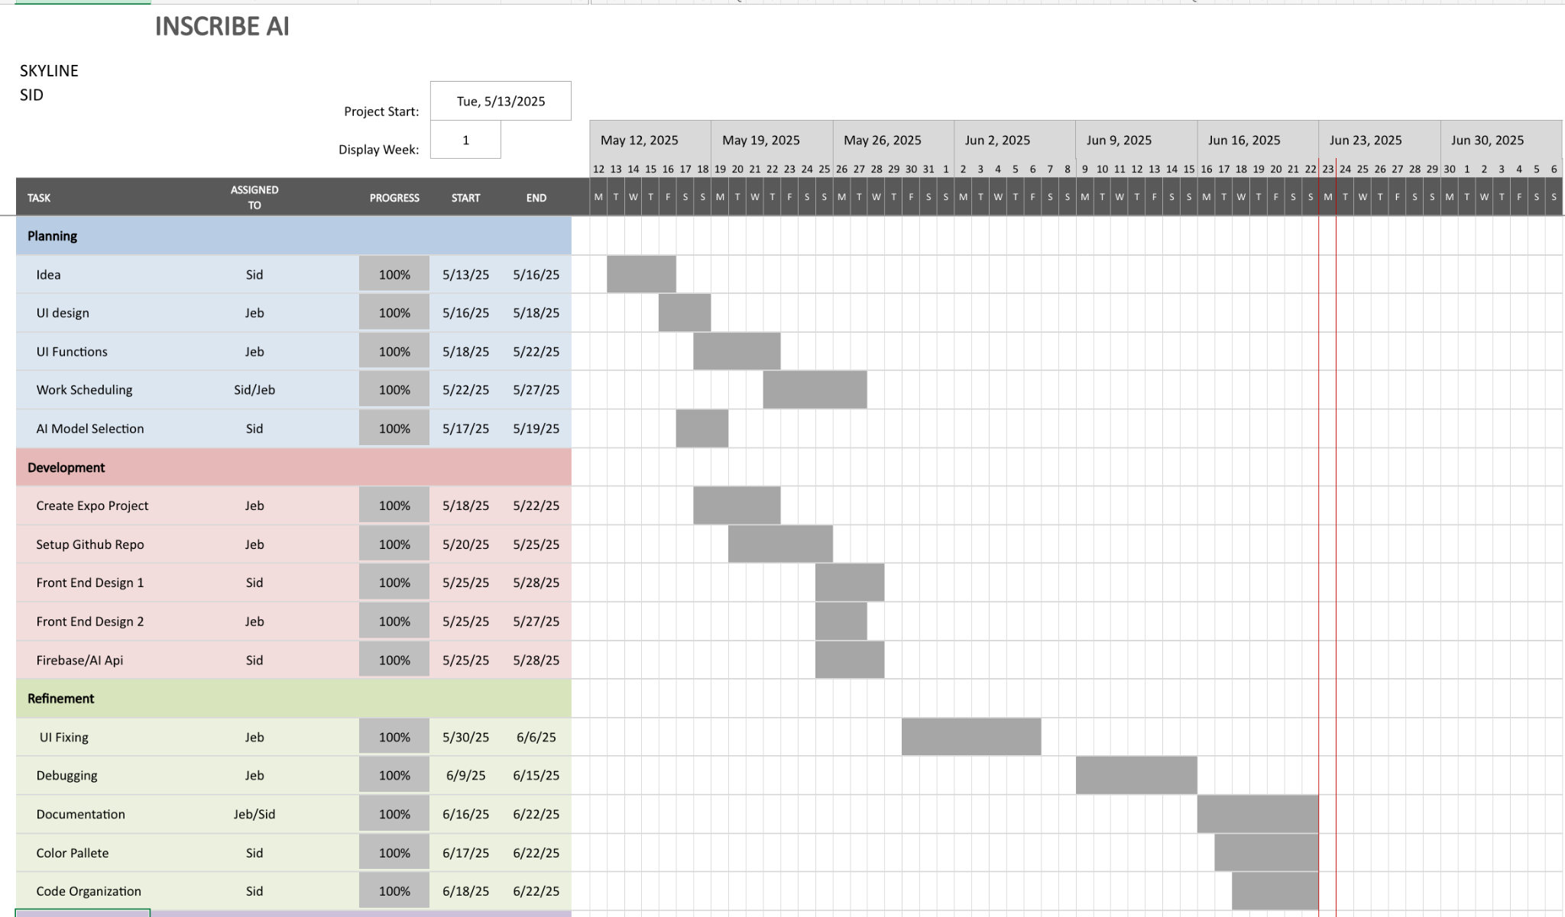

# TEST PLAN

**Component Testing:**

**Note Upload**: Manual test with good/bad lighting & different handwriting styles.  
**API Response**: Automated test to ensure valid notecard/quiz format.  
**UI Elements**: Manual testing to confirm quiz functions and progress tracking.  
**Full System Testing:**End-to-end test from image upload to quiz completion.  
Use both positive and negative test cases (clear notes vs. blurry notes).

| **Test Case ID** | **Description** | **Input** | **Expected Result** | **Actual Result** | **Status** |
| --- | --- | --- | --- | --- | --- |
| TC01 | Upload clear handwritten notes | Sharp image with legible handwriting | Notecards and quizzes are generated correctly | Notecards and quizzes generated | **Pass** |
| TC02 | Upload slightly messy handwriting | Image with minor smudges or uneven spacing | App still extracts accurate content and generates study material | Notecards and quizzes generated | **Pass** |
| TC03 | Upload blurry image | Low-quality image with some blur | App prompts for a clearer photo | Prompt displayed for better photo | **Pass** |
| TC04 | Upload blank image | Image with no visible text | App notifies user of empty content | Message displayed: “No text detected” | **Pass** |
| TC05 | Upload image with printed (typed) notes | Clean printout photo | App generates notecards and quizzes like with handwritten notes | Notecards and quizzes generated | **Pass** |
| TC06 | API response delay | Slow connection or API lag | App shows loading spinner and retries if needed | Spinner shown, response successful | **Pass** |
| TC07 | Quiz answers submitted by user | User completes quiz and submits answers | Score and stats saved to Firebase | Stats successfully saved and fetched | **Pass** |
| TC08 | Unauthorized user tries accessing app | User not logged in | App redirects to login screen | Redirect successful | **Pass** |
| TC09 | Malformed API response | Response lacks expected format | App handles error and informs user | Error message shown, no crash | **Pass** |
| TC10 | Repeated note upload | Same image uploaded twice | App still generates cards without crashing or duplicating data | Cards generated again successfully | **Pass** |

# RISKS AND CONTINGENCY PLANS

| **Risk** | **Probability** | **Mitigation** |
| --- | --- | --- |
| Poor image quality affects accuracy | Medium | Add prompt for retake or image quality check |
| API delays or failures | Medium | Retry logic + fallback message to user |
| ChatGPT output format inconsistency | Low | Pre-parse and validate responses, add fallback |
| Firebase downtime or auth failure | Low | Use local caching until retry |